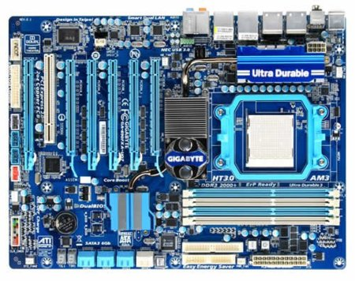

12

11

10

9

8

7

6

5

4

3

2

1

1. Socket
2. Ram erretenak
3. ATX 24
4. Ide konektore
5. Ide konektore
6. South bridge disipadore
7. Pila
8. Front panel konektore
9. Pci
10. Pci Express
11. North bridge disipadore
12. Atx x 8